
Data
Analysis

Luis Carlos Guevara
Faculty of Finance,
Government and International Relations

2026-I
Notes on the Installation of R and RStudio, and the use of R Markdown

R, RStudio, and R Markdown

How to install
is a system for statistical calculations, table and data management, and graphic generation, among other functions. It is comprised of a dedicated language and execution environment.
- The language allows for control structures such as branching and loops.
- It supports modular programming through functions, which can be built by users or other contributors.
- It has a wide set of statistical procedures, such as linear and generalized models, time series analysis, parametric and non-parametric tests, clustering, and smoothing.
- It offers a set of functions dedicated to the creation of graphs and data representations.
- It allows for the installation of “add-on packages” for specific purposes, further expanding its functionality.

¿Where to install ?
Windows | https://cran.rstudio.com/bin/windows/base/R-4.5.2-win.exe
MacOS | https://cran.rstudio.com/bin/macosx/big-sur-arm64/base/R-4.5.2-arm64.pkg
After installing R, it is possible to install . It is an integrated development environment (IDE) for R, which includes a console, a syntax editor (for the codes we will write), and support for direct code execution.
- RStudio also contains tools that facilitate workflow, such as exploring objects (data, vectors, matrices, lists, and functions).
- It includes command history and variable lists.
- It can be understood as an interface for working with R, providing friendlier and more organized experience for writing code, debugging data, and visualizing results
¿ Where to install ?
Windows | https://download1.rstudio.org/electron/windows/RStudio-2026.01.0-392.exe
MacOS | https://download1.rstudio.org/electron/macos/RStudio-2026.01.0-392.dmg
The user interface (UI) structure of RStudio is described by four sections
Script Editor: This is where code is written and edited; here, routines, functions, and statistical analyses for the course will be developed. Scripts can be saved to files for reuse or sharing, and the editor allows for direct execution of lines or blocks of code.
Console: This is where code is executed and the results of commands are presented. Commands can also be written directly here for immediate responses
Environment and History: Contains information on the variables, objects, data, and functions actively used in the session, as well as command history. This section serves as a control center for managing the workspace.
Help, Graphics, and Packages: Used to manage files and explore generated graphics. It allows for opening data files, visualizing graphics directly in RStudio, exploring installed packages, and searching for command information in the documentation.
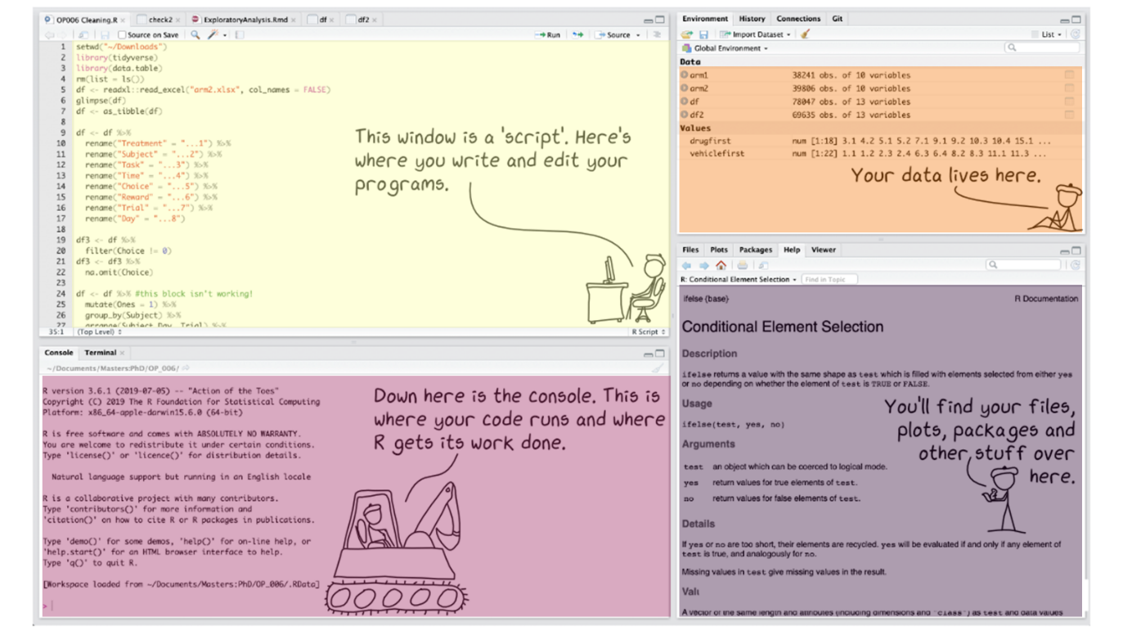
Taken from https://bionesiacourse.github.io/2021Course/setup.html

R Markdown
R Markdown provides an authoring framework for data science, allowing code to be saved and executed while generating high-quality reports from a single file.
- It enables the reproducibility of results: both the code and the textual interpretation are in the same document.
- Results are generated automatically from the source code.
- It can be used as a library within R.

# Installs Rmarkdown from CRAN
install.packages('rmarkdown')

# Installs Tinytext from CRAN for PDF compilation
install.packages('tinytex')
tinytex::install_tinytex()

After installing the library, you can start a new document via the File menu. Markdown documents use a specific file type: .rmd.
- Select File > New File > R Markdown (Steps 1 and 2).
- Provide a title and a date (Steps 3 and 4).
- Choose a format: HTML, PDF, or Word. In this course, we will mostly use PDF (which requires the tinytex package)
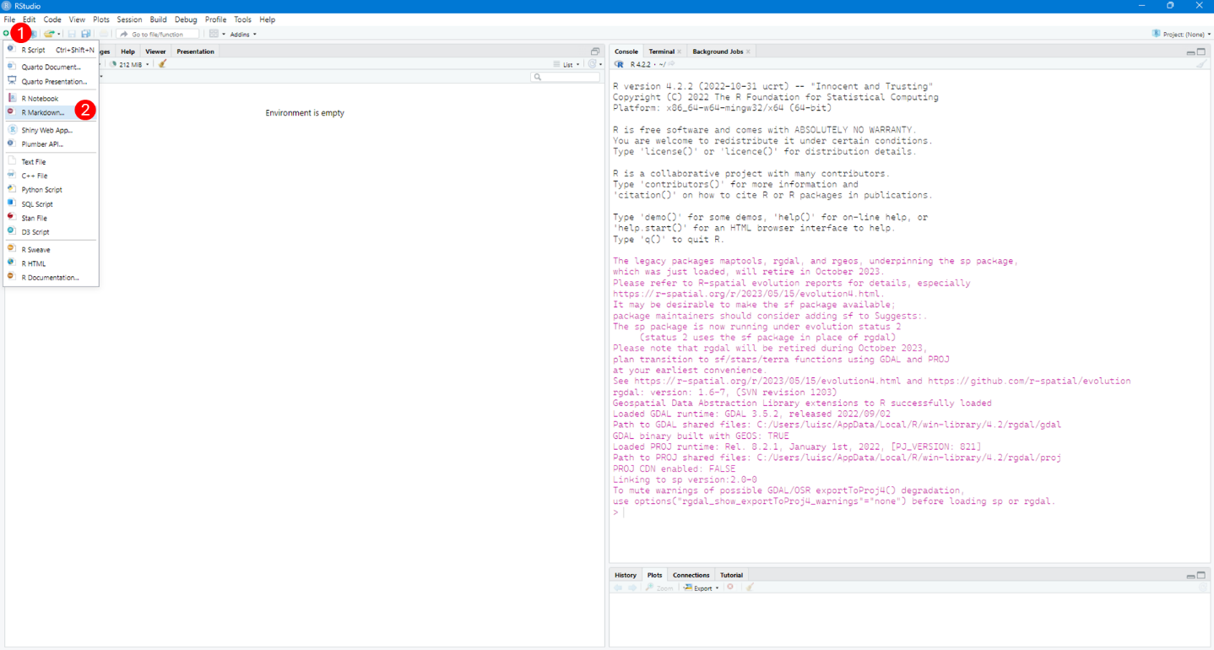
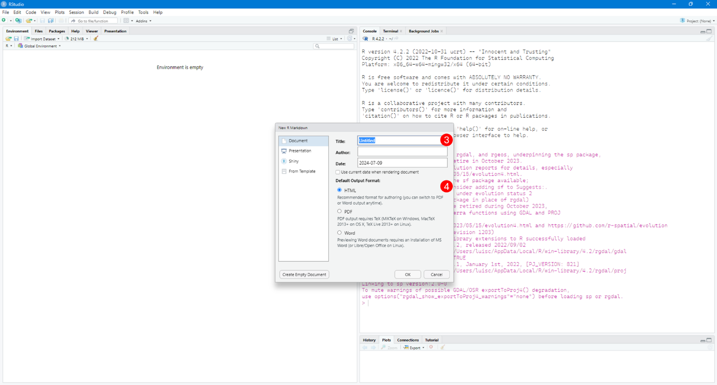
A template consists of three types of elements:
- Metadata (Orange): Facilitates the construction and compilation of the document.
- Code Chunks (Purple): Where commands, functions, and operations are written using the R language.
- Text (Violet): Not conditioned by R language elements; mostly incorporates elements similar to HTML text construction.
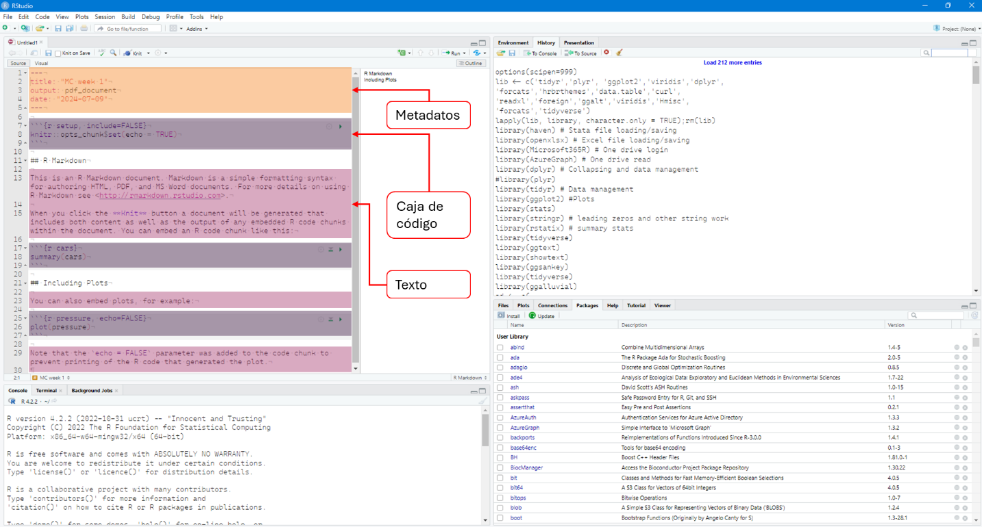
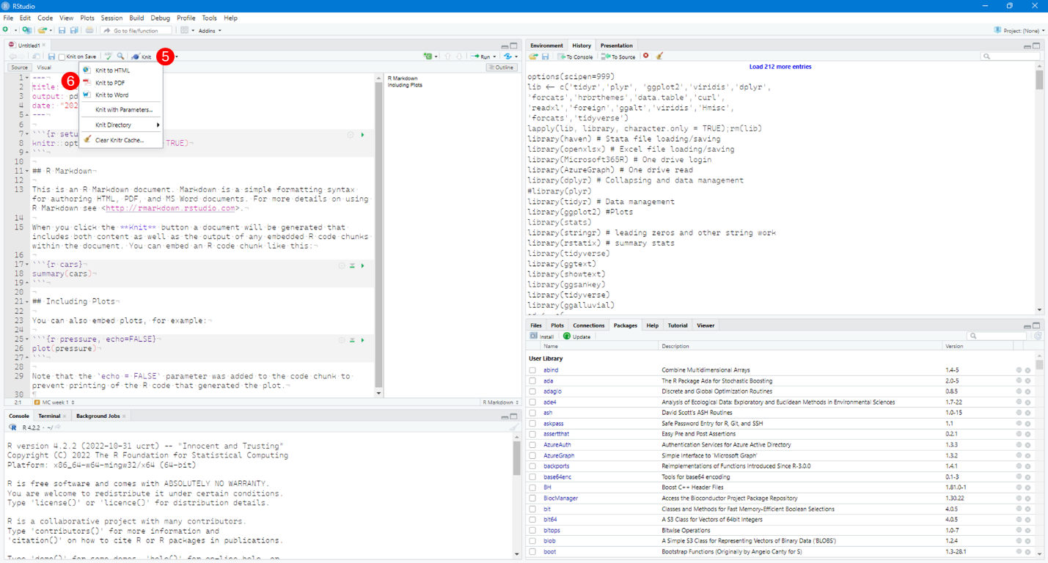
To compile the document, use the Knit option (Step 5). You will then be prompted for a file name and directory to export the final PDF
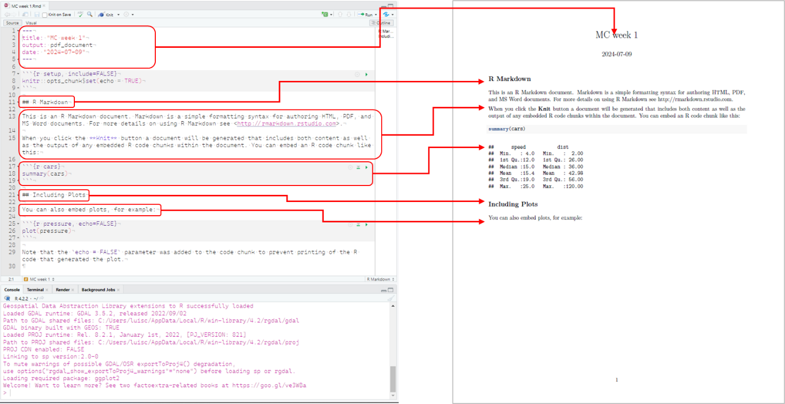
Additional Resources
- Introduction to R Markdown: https://rmarkdown.rstudio.com/lesson-1.html or https://bookdown.org/yihui/rmarkdown/.
- Introduction to RStudio: https://education.rstudio.com/learn/beginner/.

